Wiffle Ball Study Guide
- Force Play: A play in which the runner must advance to the next base if the ball is hit on the ground or not caught in the air.
  - To get a runner out during a force play, the fielders may tag the base to get the runner out
  - Example: If a runner is on first base, the next batter hits the ball on the ground, the runner at first base must advance to second base. The fielding team can tag second base (with possession of the ball) to get the runner out.
- Foul ball occurs when the ball is hit to the right of first base and the left of third base
- “Fly ball” occurs when the ball is hit in the air to the outfield
- “Pop fly” occurs when the ball is hit in the air in the infield
- “Tagging up: The term used when the runner waits until after the ball is caught in the air and runs to the next base.
  - If a player “tags up” the fielding team must tag the runner in order to get them out
  - Base runners should wait to see if the ball is caught in the air to determine if they need to either advance to the next base, go back to the original base if the ball was caught, or to tag up
- The batter only has 3 pitches to hit the ball
- “Ground ball” occurs when the ball is hit on the ground
- Outs: A player is out when:
  - A fielder tags the runner
    - If there is not a force play, the fielding team must tag the runner in order to get them out
      - Example: There is a runner on 3rd base but not on second, in order to get the runner from 3rd base out the fielding team must tag them
  - A fielder tags the base with possession of the ball on a force play before the runner makes it to the base
  - A fielder catches the ball in the air (including a foul ball)
  - The batter does not hit the ball in play after 3 pitches
  - A base runner runs to the next base after the ball was caught in the air and did not tag up
  - Slings or throws the bat

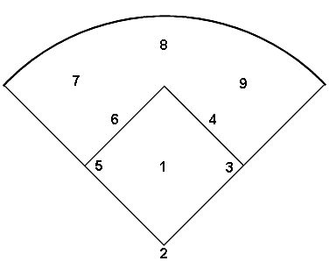
Softball Study Guide

1. Pitcher
2. Catcher
3. 1st base
4. 2nd base
5. 3rd base
6. Short stop
7. Left field
8. Center field
9. Right field

