TEAM HANDBALL STUDY GUIDE

HISTORY

Team handball originated in Germany in the 1900’s and became an Olympic sport for men in 1972 in Munich, Germany and the 1976 Summer Olympics for women. Team Handball is an exciting, and intense sport. Players enjoy this sport because it is a fast paced sport. Team Handball is actually the second most popular sport in Europe next to soccer and it is still on the rise in the United States. Teamwork is one of the most important qualities it takes to be successful in Team Handball.

OBJECTIVE

The object of team handball is to score a goal by passing the ball quickly and throwing the ball past the defense and goalie into the goal. A regulation game consists of 2 30-minute halves with a 10 minute intermission. The only breaks in the game occur when an injury occurs. During PE, we play based on the amount of time remaining in class.

RULES

- A team shall consist of a 1 goalie and 6 court players – left & right wing, circle runner, left, right & center backcourt.
- Play begins with a center throw-off (sometimes called a throw-on) by one team determined by a coin toss or Rock-Paper-Scissor.
- Both teams must begin on their own half of the court.
- A goal is worth 1 point. In a regulation game the entire ball must cross the goal line for the point to count.
- After a goal is scored a center throw-off is awarded to the opposing team.

- Court players may do the following:
  - Hold the ball up to 3 seconds
  - Run 3 steps with the ball
  - Dribble as many times as desired
  - Pass or shoot
  - Run 3 steps before and after a dribble
- Court players may not do the following:
  - Use their arms or legs to push, grab, tackle, kick or hold on opponent
  - Kick the ball
  - Make contact with the ball below the knees
  - Double dribble
  - Step on or across the goal area line
  - Air dribble
- Goalies may do the following:
  - Defend the goal in any way using hands, feet and body
  - Take more than 3 steps when carrying the ball in the goal
  - Hold the ball longer than 3 seconds
  - Move outside the goal area and throw for a goal, but must abide by the rules for court players

- Goalies may not do the following:
  - Leave the goal area while in possession of the ball
  - Pick up a ball outside the goal area and carry it back into the goal area

STRATEGIES

Basic 1-on-1 and zone defenses are used in the game. Beginners will be most successful using a 1-on-1 (man to man) defense. Bounce passes are most effective when moving the ball between players. Basketball and soccer offensive and defensive strategies can be used quite easily in team handball.

VOCABULARY

- Assist: a pass that directly leads to a goal by a teammate
- Checking: attempting to prevent an opponent from gaining an advantage (body checking)
- Crease: this is the half circle/rectangular box in front of the goal (goal box)
- Clearing: sending the handball out of the attack zone
- Dribbling: moving the ball around by bouncing the ball with one hand maintaining control
- Throw-off: starts the game and follows each goal
- Throw-in: taken from the sideline after the ball travels out of bounds
- Goal: a handball that is scored inside the goal area
- Goal-throw: a throw made by the goalie from outside the goal area upon retrieving a loose ball outside the goal area
- Throw-out: a throw made by the goalie if the ball is caught or blocked inside the goal
- Free-throw: awarded for a rule violation by the goalie or a court player. The free-throw is taken closest to where the violation occurred.
- Passive play- if teams are just passing around with no attempt to score ball will be awarded to other team

Diagram of Team Handball Court
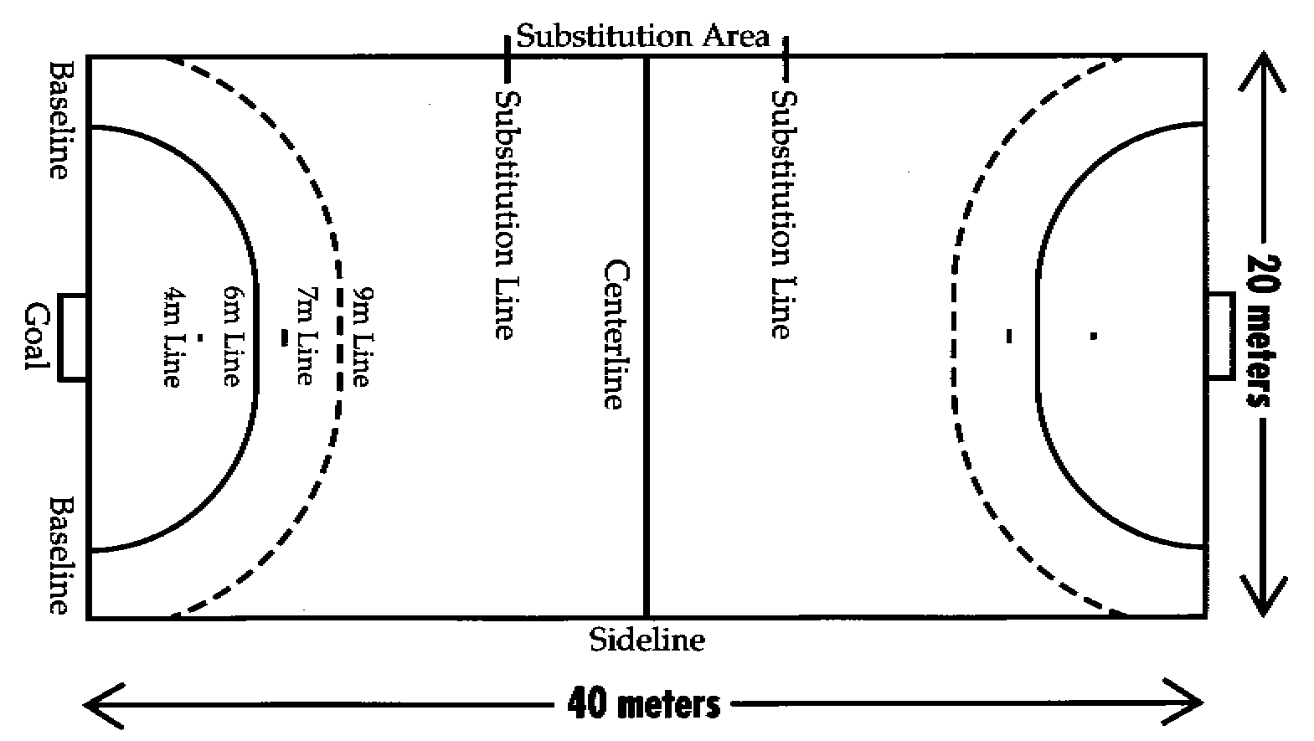
Diagram of a team handball court is from the web site for
USA Team Handball (http://www.usateamhandball.org/

