Badminton Study Guide

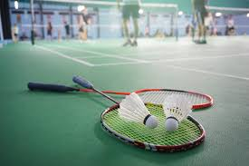
Forehand grip
- This grip is used to hit shots that are of the forehand side of your body and around the head shots
- Racket should be perpendicular to the floor
- Place your hand on the handle as if you are shaking hands with it
- There should be a V shape in between your thumb and index finger
Backhand grip
- This grip is used to hit shots that are on the backhand side of your body
- Placing your thumb against the back bevel of the handle allows for greater leverage and power
The serve
- The serve is to be performed underhand
- The entire birdie should be below waist level before hitting
- The serve is to cross the net diagonally to the receivers court
- The MOST important shot in badminton because it is the one shot you have complete control over.
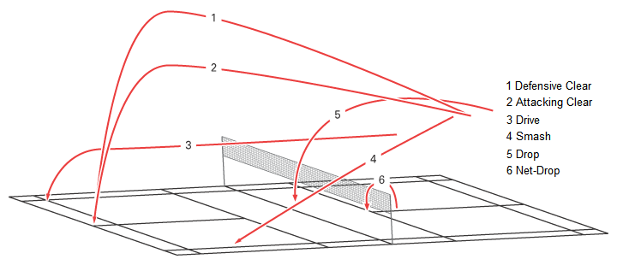
Defensive clear
- High and deep trajectory
- These type of shots give you more time to return to your base and prepare for the next shot
Attacking clear
- Has trajectory that runs almost parallel to the ground
- The shuttle travels fast and flat towards your opponents backcourt.
- Allows less time for your opponent to get behind the shuttle to return
Drive
- Shots that cross the net flatly in a horizontal trajectory
- The drive is an attacking shot that is usually played from the sides of the court when the shuttle has fallen too low to be returned as a smash
- Goal is to get the shuttle behind your opponent
Drop shot
- Use this shot to move your opponent to the front court. It will create space in the midcourt and backcourt for you to exploit.
Net drop shot
- This drop shot should land in your opponent’s front court area as close to the net as possible.
- It’s intended to move your opponent to the frontcourt and force a weak return or no return.

Smash
- The smash is a hit with power and speed downward.
- The angle and speed will make it hard for your opponent to return the hit and there is almost no defense against a well executed smash.
Where to stand while serving
- If your score is even, you should serve from the right service court (i.e. 0, 2.4,6, etc.)
- If your score is odd, you should serve from the left service court (i.e. 1, 3, 5, 7, etc.)
- Foot fault can be called if foot touches the line or goes over the line.
- Serves should be underhand and below the waist (after the serve hits can be overhand or underhand)
- Only the designated receiver can return the serve
- The serve MUST be hit diagonally to the proper service area
- LET SERVE- birdie or shuttle hits the top of the net and goes over; if this happens, re serve
Rally scoring
- The point will go to the side that wins the rally
- The match will be played best 2 out of 3 games and we will play to 21.
- If score is 20-20, the first to gain a 2 point lead wins the game.
- After the first game has concluded, the team that won gets the first serve in the next game.
Badminton faults
- Contact is made with the shuttle above the waist during the serve
- Shuttle lands in the wrong service court during the serve
- Shuttle lands out of bounds (on the line is GOOD)
- Shuttle goes under the net
- Shuttle does not cross the net
- Shuttle is hit more than once while on your side of the net
- Net is touched by anything other than the shuttle
- Shuttle is carried or thrown with the racket

